Radiation in the atmosphere of Venus
D.V. Titov¹, D. Crisp², E. Lellouch³, V.I. Moroz⁴, A.V. Rodin⁴, F.W. Taylor⁵
¹⁾Max-Planck-Institut fr Aeronomie, Katlenburg-Lindau, Germany; ²⁾JPL, NASA, California, USA; ³⁾Observatoire de Meudon, Paris, France; ⁴⁾Space Research Institute (IKI), Moscow, Russia; ⁵⁾University of Oxford, UK.

Introduction. Radiation plays an important role in various processes on the planets. It defines temperature structure, controls photochemistry, induces atmospheric motions. Radiation is also the main “carrier” of information about the composition, the temperature, and the atmospheric dynamics. That is why remote sensing experiments to measure the radiation field are the main payload components of planetary spacecraft missions. This paper focuses on what is known about the radiation escaping from Venus, briefly describes the main results on the radiation field in the deep atmosphere, and lists the main open questions.
Outgoing radiation. While observing Venus from space one can distinguish three types of radiation escaping from the planet. The first one is the reflected solar radiation which dominates between 0.2 μm and ~3 μm (Fig. 1). It forms essentially in the upper cloud (~65km) and bears the information about the properties of cloud top and the atmosphere above it. Venus has very high spherical albedo in the visible (~85%) due to scattering of the solar radiation by dense clouds [1]. The second type of radiation observed from space is thermal emission at wavelengths longer than ~1μm. Altitude region of its formation varies from the mesosphere (60 – 100km) at λ ≅ 3μm ÷ 1mm down to the lower atmosphere and even the surface at λ ≅ 1μm ÷ 2.3μm. The discovery of the near IR spectral “windows”, in which the thermal radiation leaks to space from below the clouds, gives excellent opportunity to study the lower atmosphere from orbit. However these emissions are very weak and can be observed on the nightside only. Spectroscopy and spectro-imaging of thermal radiation can be used to study the composition, the temperature and the cloud structures, and the dynamics from ~100 km down to the very surface. Airglows of various molecules (O₂, NO etc.) form the third type of radiation [5]. They consist of narrow lines emitted by the atoms in the UV though near IR. Airglow emissions are rather weak (~10³ Rayleigh) and can be observed only on the nightside except for that of O₂ at 1.27 μm (~10⁶ R) that is visible even on the dayside. The airglows originate in the lower thermosphere (100-150km) following recombination of molecules and can be used as tracers of the thermospheric global circulation.
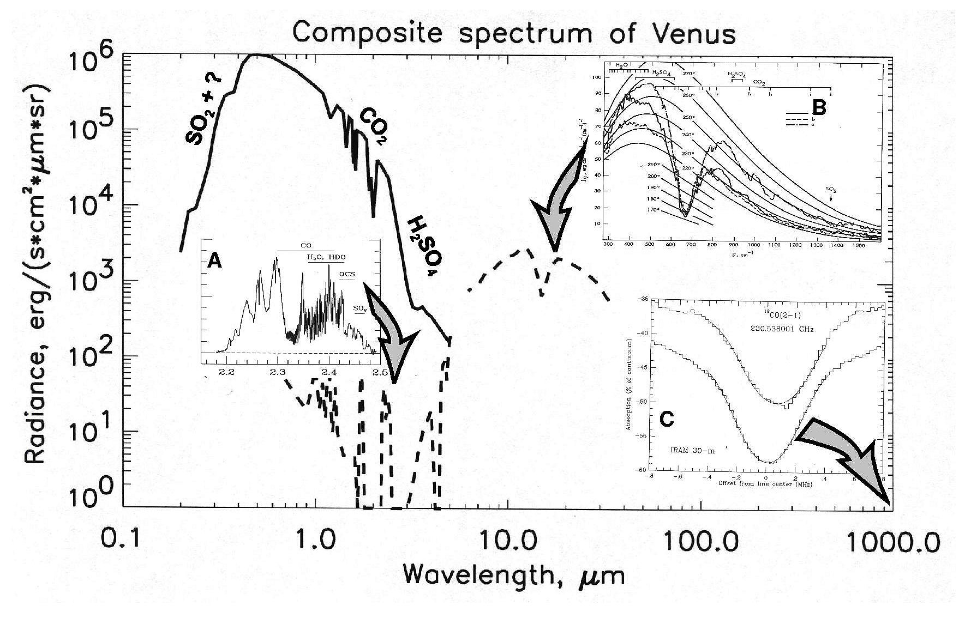
Figure 1. Composite spectrum of Venus: reflected solar radiation (solid line) and thermal emission (dashes). (Airglow spectra are not shown.) Parts of the spectrum are shown in detail in the blow-up windows: A. High resolution spectrum of the Venus nightside in the 2.3μm “window” [2]; B. Typical spectra of Venus thermal emission from FTSE/Venera-15 [3]; C. Very high resolution microwave spectrum of CO line [4].
Radiation in the deep atmosphere. The deep atmosphere radiation field is formed by the processes of multiple scattering, absorption, and emission. Distribution of radiation was studied only in few locations by the Venera and the Pioneer Venus descent probes and the Vega balloons. The intensity of scattered solar light decreases downward with only ~10% of incident solar flux reaching the surface [6] (Fig. 2). The decrease is even faster inside the near IR absorption bands of the atmospheric gases and in the “blue” portion of the spectrum.
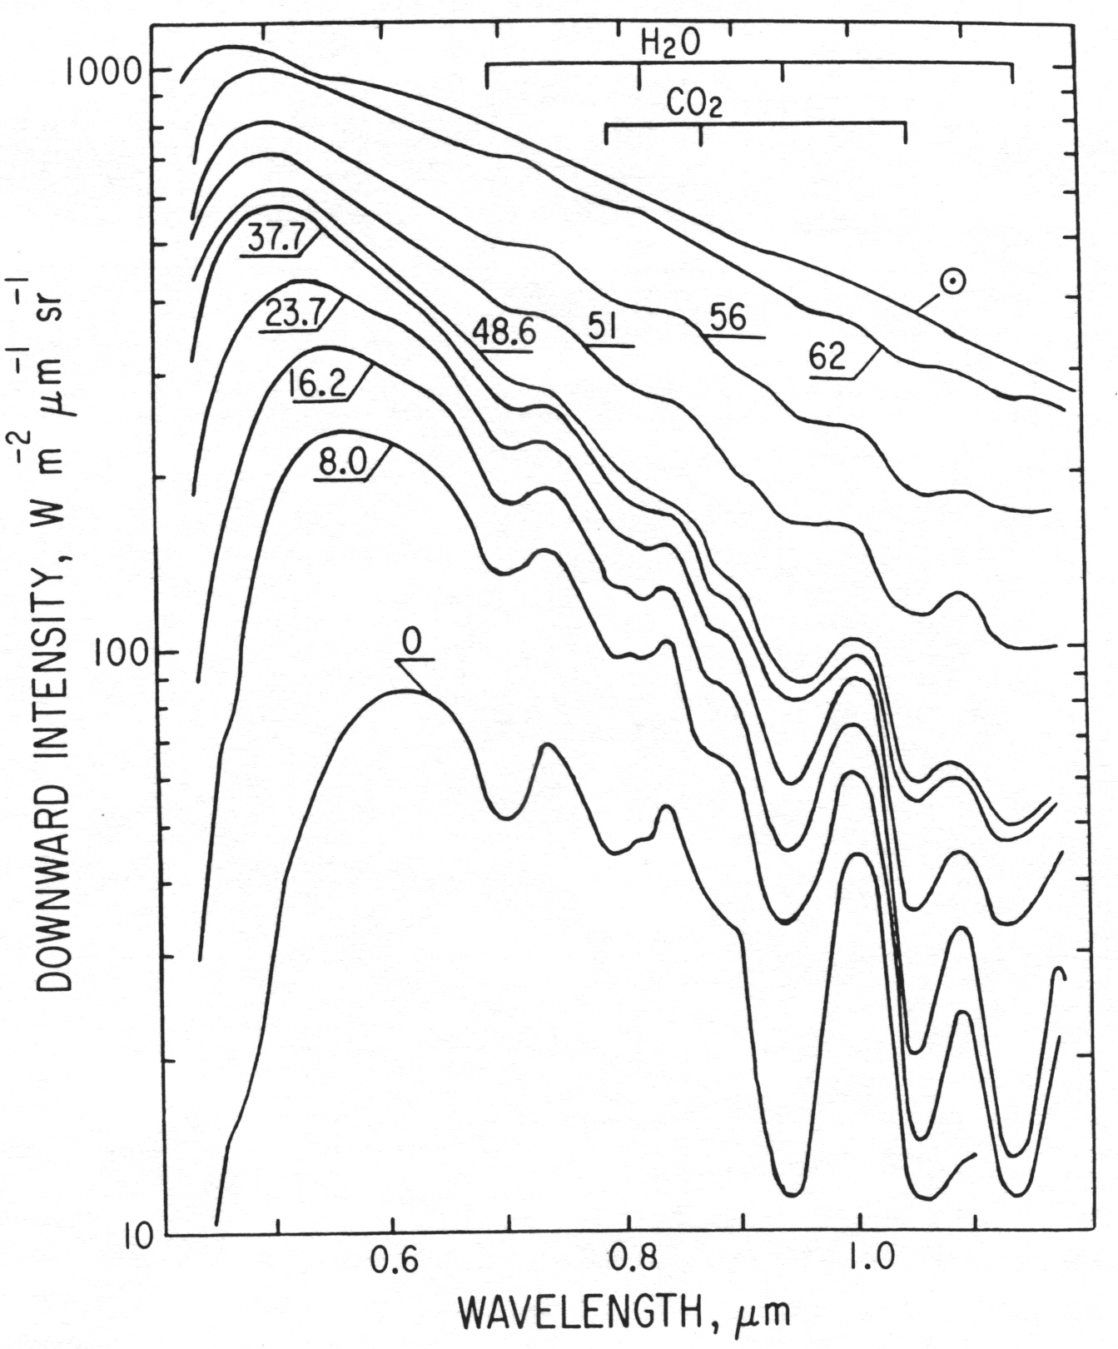
Figure 2. Spectra of scattered solar radiation from zenith direction measured by Venera-11 descent probe [6]. Figures at the curves mark altitudes.
Radiative energy budget. Thermal flux escaping from Venus to space is virtually constant with latitude and local solar time. Since solar radiation is absorbed mainly at low latitudes such distribution implies significant energy transport by atmospheric circulation [7, 8]. At mesospheric levels the radiative energy balance results in the net heating at low and net cooling at middle and high latitudes that again indicates poleward energy transport [9]. In the lower atmosphere the balance between solar heating and thermal cooling results in very strong (~500K) greenhouse effect caused by the presence of CO₂, H₂O, H₂SO₄ (clouds) and other “greenhouse” species.
Open questions. Despite extensive Venus exploration in 70-80-s significant gaps in our knowledge of the radiation field outside and inside the Venus atmosphere still remain. They are: 1) Detailed study of the thermal emission from the lower atmosphere in the near IR spectral “windows”; 2) Measurements of the outgoing thermal radiation with complete latitude and local time coverage; 3) Detailed mapping of the distribution and variations of the airglows; 4) Measurements of the scattered solar radiation and thermal radiation field in the deep atmosphere. Filling these gaps would help to solve the key problems of the Venus’ atmosphere composition, structure and dynamics. The second group of problems is directly related to the radiative transfer and heat balance: 1) Radiative energy balance as function of altitude and latitude; 2) Role of various species in the Venus’ greenhouse; 3) Accurate characterization of the far wings of spectral lines at Venus conditions.
References. [1] Moroz, in Venus-1 book, p27, 1983; [2] B☺zard et al., Nature 345, p508, 1990; [3] Oertel et al., Adv. Space Res 5(9), p25, 1985; [4] Lellouch et al., in Venus-2 book, p295, 1997; [5] Bougher et al., in Venus-2 book, p259, 1997; [6] Ekonomov et al., in Venus-1 book, p632, 1983; [7] Taylor et al., in Venus-1 book, p650, 1983; [8] Moroz et al., Adv. Space Res., 5(11), p197, 1985; [9] Crisp&Titov, in Venus-2 book, p353, 1997.

